A

Project Report

On

**“ONLINE FOOD PLAZA”**

Submitted in partial fulfillment of

The requirements for the 6th Semester Sessional Examination of

BACHELOR OF TECHNOLOGY

IN

**INFORMATION AND TECHNOLOGY**

By

**SHIVNATH DUTTA (14IT002)[ 1401210324]**

**VIPUL ANAND (14IT005) [1401210329]**

**ALOK RANJAN MISHRA (14IT009)[ 1401210317]**



**DEPARTMENT OF COMPUTER SCIENCE & ENGINEERING**

**GANDHI INSTITUTE OF ENGINEERING AND TECHNOLOGY**

**GUNUPUR – 76502**



**Department of Computer Science & Engineering**



**CERTIFICATE**

This is to certify that the project work entitled “**ONLINE FOOD PLAZA**” is done by **ALOK RANJAN MISHRA, (1401210317)**  , **VIPUL ANAND** (**1401210329) , SHIVNATH DUTTA(1401210324)** in partial fulfillment of the requirements for the 7th Semester Sessional Examination of Bachelor of Technology in Computer Science Engineering during the academic year 2017-18. This work is submitted to the department as a part of evaluation of 6th Semester Project.

Prof.(Dr) Nilambar Sethi Prof. Mr.Sanjay Kunuar Project Incharge HoD, CSE

ACKNOWLEDGEMENT

Our Sincere thanks to **Prof. Sanjay Kumar Kunuar**, Head Of Department of CSE, Gandhi Institute Of Engineerinig And Technology Gunupur for his encouragement and valuable suggestions during the period of my project.

We express our heartfelt gratitude to **Prof. (Dr.) A.V.N.L Sharma**, Principal GIET Gunupur for permitting us to carry out this Project work.

**ALOK RANJAN MISHRA**

**VIPUL ANAND**

**SHIVNATH DUTTA**

CONTENTS

* Abstract…………………………
* Introduction……………………..
  + - Project Purpose
    - Project Scope
    - Project Features
* System Analysis………………
  + - User Requirement
    - Hardware Requirement
    - Software Requirement
* System Design and Specification
  + - Project Model
    - DFD
    - E-R Diagram
    - Use Case Diagram
    - Screen-shorts
* Testing…………………………
  + - Unit Testing
    - Integration Testing
* Limitations…………………….
* Conclusion…………………….

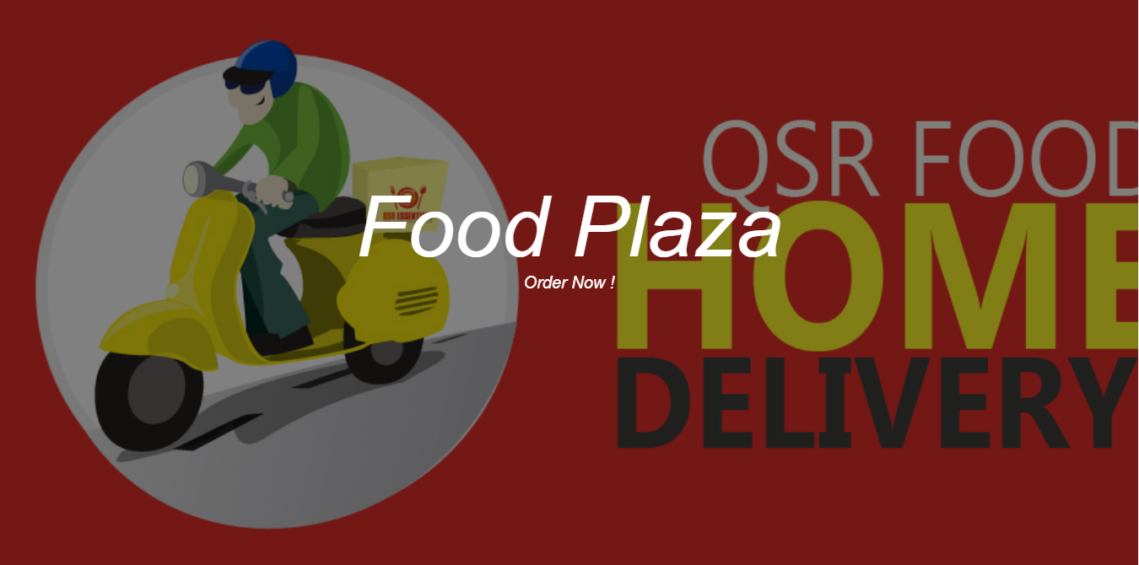

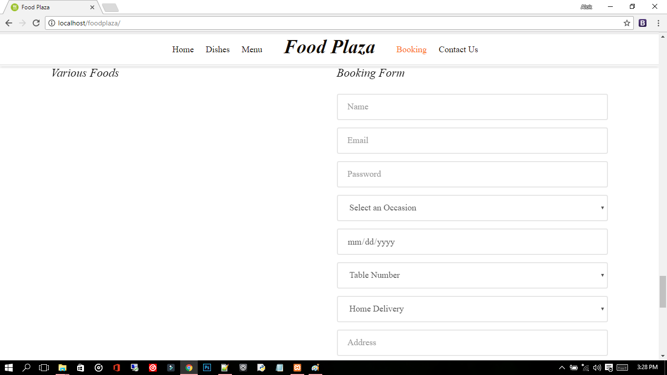

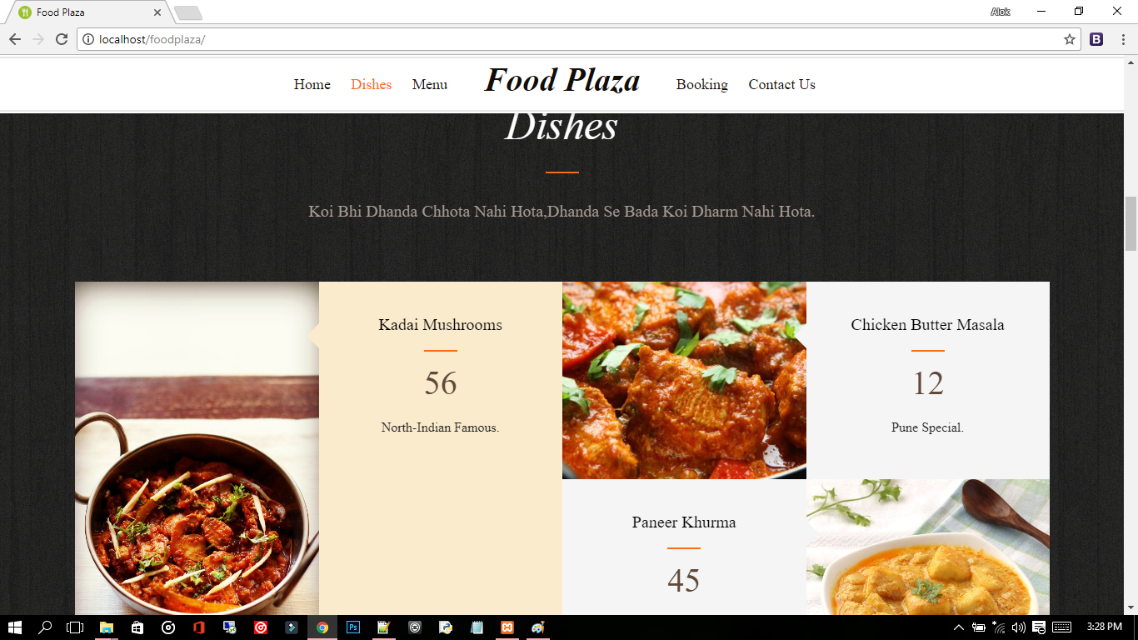

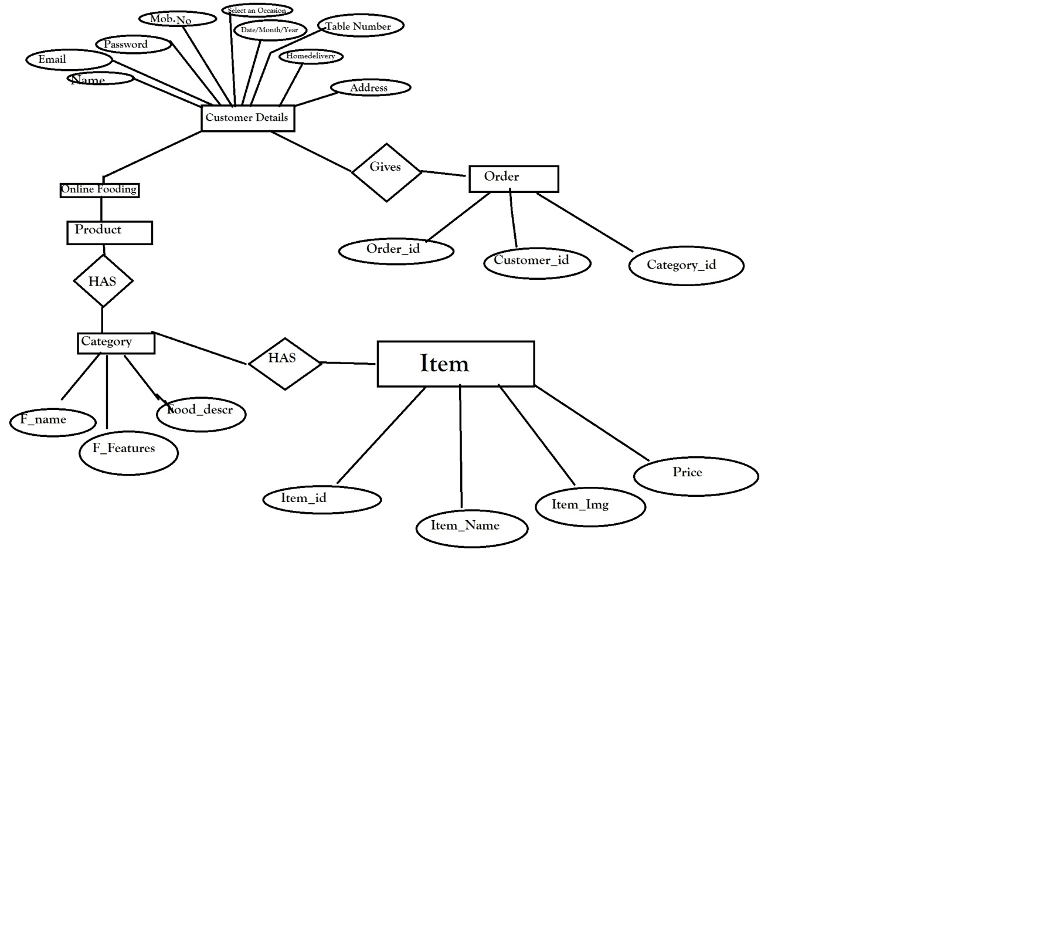

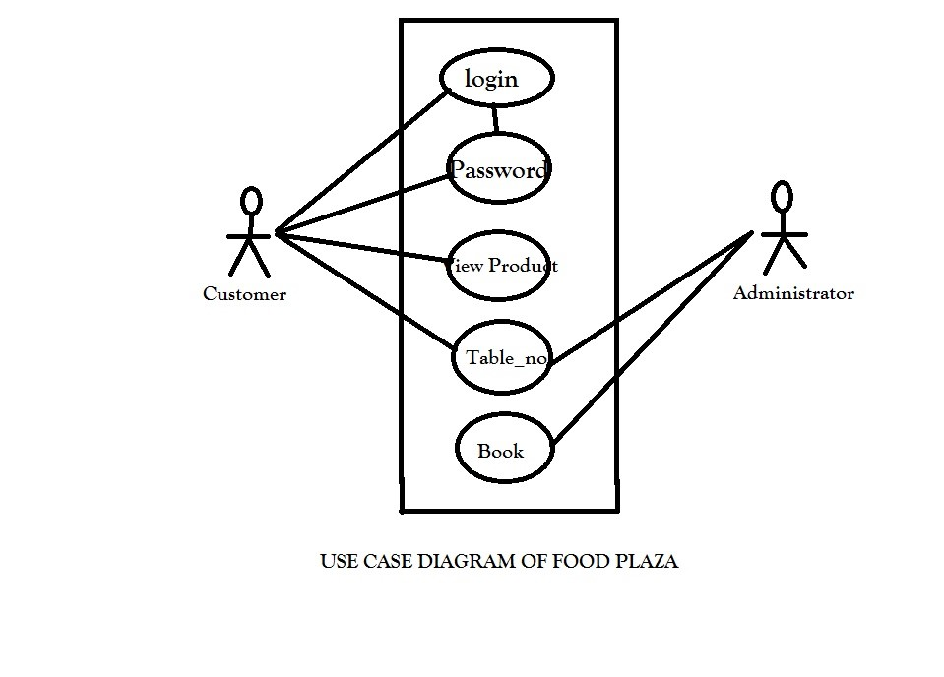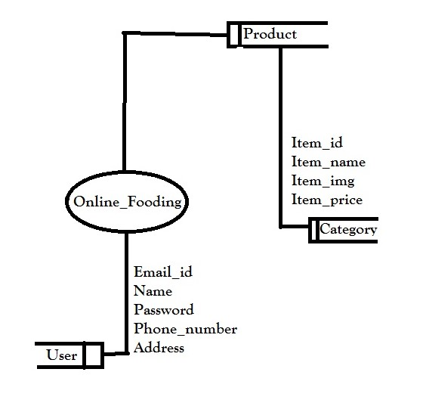

**Software Requirements**

1. Front-End -HTML,CSS

BOOTSTRAP

1. Database-my SQL
2. Backend-PHP
3. XAMPP SERVER